Code:

ny2 <- read.csv('C:/Users/dingj/Desktop/data_analytics/hw2/nyt2.csv')

attach(ny2)

ny3 <- read.csv('C:/Users/dingj/Desktop/data_analytics/hw2/nyt3.csv')

attach(ny3)

ny4 <- read.csv('C:/Users/dingj/Desktop/data_analytics/hw2/nyt4.csv')

attach(ny4)

ny5 <- read.csv('C:/Users/dingj/Desktop/data_analytics/hw2/nyt5.csv')

attach(ny5)

ny6 <- read.csv('C:/Users/dingj/Desktop/data_analytics/hw2/nyt6.csv')

attach(ny6)

boxplot(ny2$Age,ny3$Age,ny4$Age,ny5$Age,ny6$Age)

boxplot(ny2$Impressions,ny3$Impressions,ny4$Impressions,ny5$Impressions,ny6$Impressions)

hist(ny2$Age)

hist(ny3$Age)

hist(ny4$Age)

hist(ny5$Age)

hist(ny6$Age)

hist(ny2$Impressions)

hist(ny3$Impressions)

hist(ny4$Impressions)

hist(ny5$Impressions)

hist(ny6$Impressions)

plot(ecdf(ny2$Age),verticals=TRUE)

plot(ecdf(ny3$Age),verticals=TRUE)

plot(ecdf(ny4$Age),verticals=TRUE)

plot(ecdf(ny5$Age),verticals=TRUE)

plot(ecdf(ny6$Age),verticals=TRUE)

plot(ecdf(ny2$Impressions),verticals=TRUE)

plot(ecdf(ny3$Impressions),verticals=TRUE)

plot(ecdf(ny4$Impressions),verticals=TRUE)

plot(ecdf(ny5$Impressions),verticals=TRUE)

plot(ecdf(ny6$Impressions),verticals=TRUE)

shapiro.test(ny2$Age[1:5000])

shapiro.test(ny3$Age[1:5000])

shapiro.test(ny4$Age[1:5000])

shapiro.test(ny5$Age[1:5000])

shapiro.test(ny6$Age[1:5000])

shapiro.test(ny2$Impressions[1:5000])

shapiro.test(ny3$Impressions[1:5000])

shapiro.test(ny4$Impressions[1:5000])

shapiro.test(ny5$Impressions[1:5000])

shapiro.test(ny6$Impressions[1:5000])

boxplot(ny2$Clicks,ny3$Clicks)

hist(ny2$Clicks)

hist(ny3$Clicks)

plot(ecdf(ny2$Clicks),verticals=TRUE)

plot(ecdf(ny3$Clicks),verticals=TRUE)

shapiro.test(ny2$Clicks[1:5000])

shapiro.test(ny3$Clicks[1:5000])

Problem1:

a.The box plot for Ages

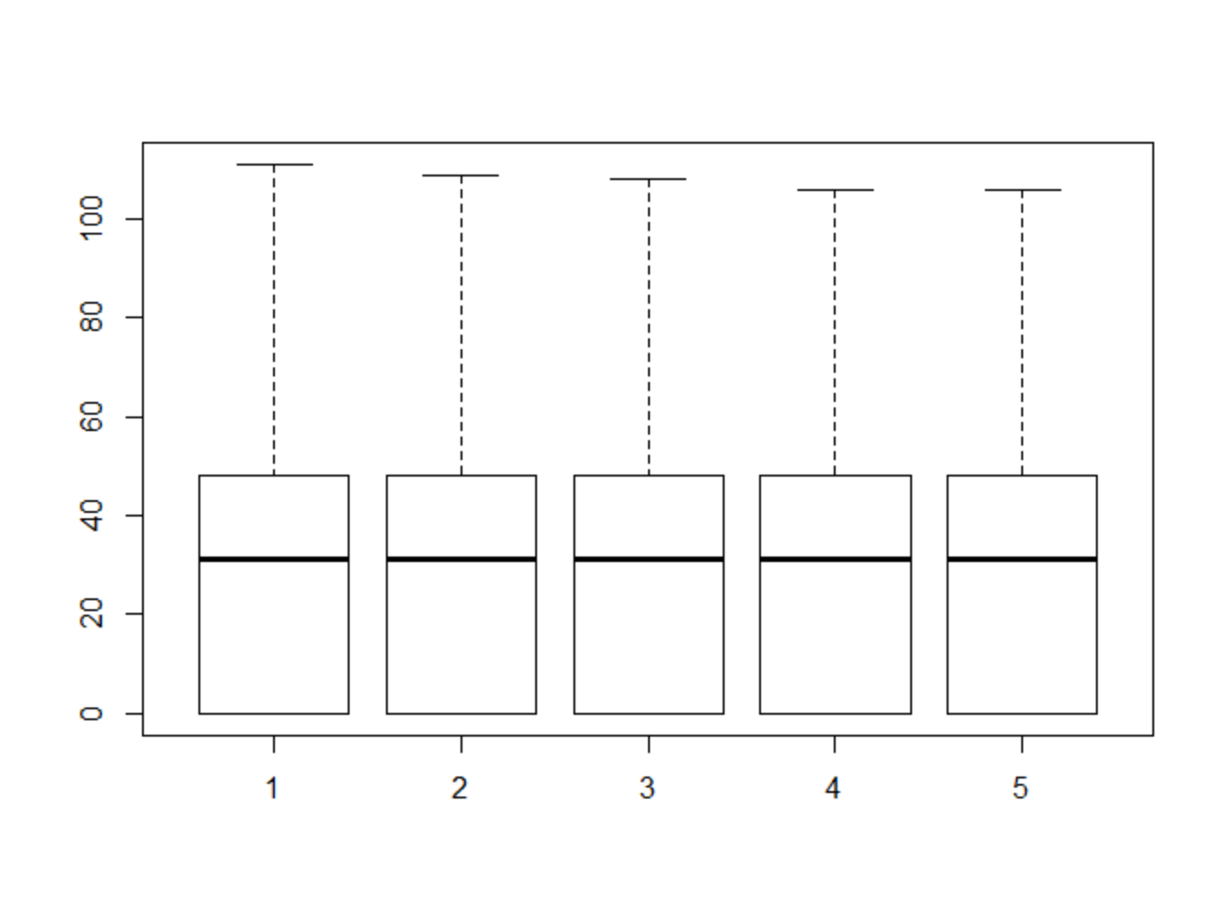

The box plot for Impressions

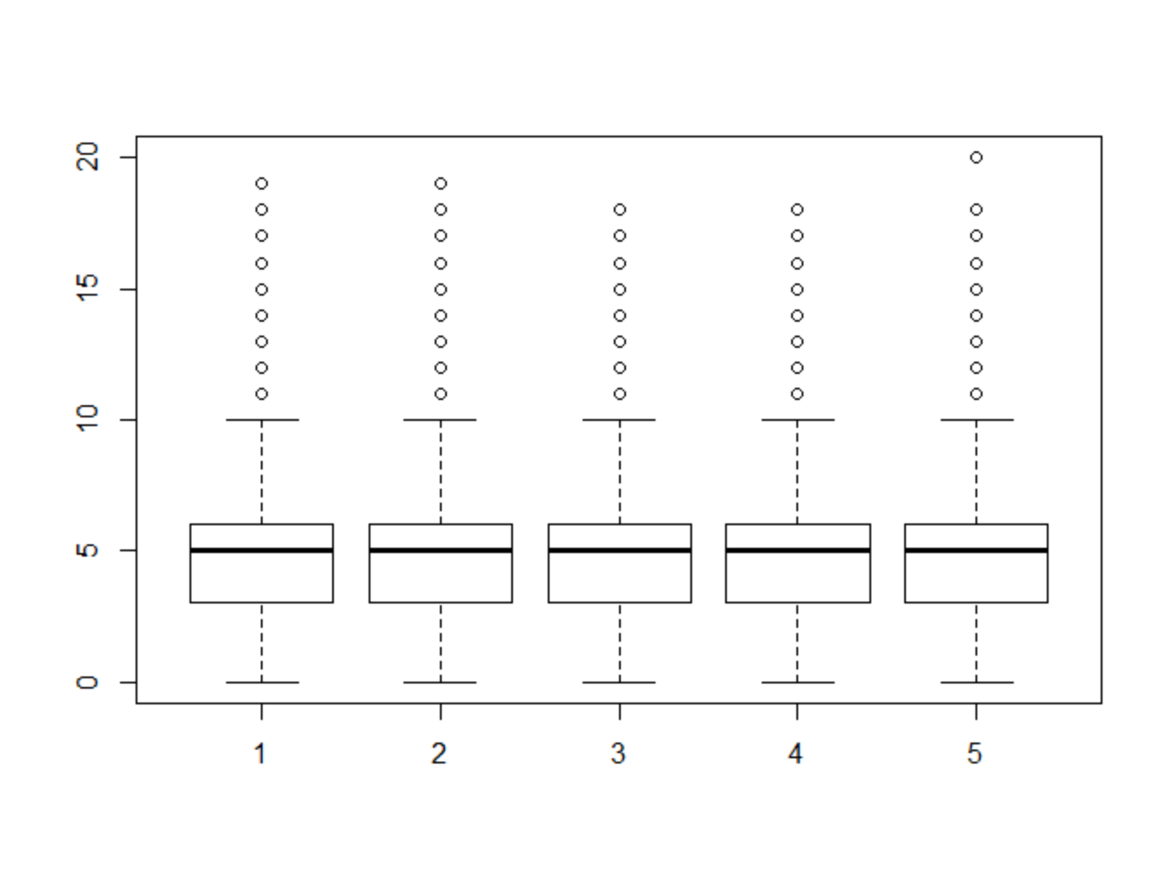

From the boxplot for ages, the average ages of the New York times readers are around 30 years old and average impressions are 5. The average ages and impressions are almost the same across different datasets. The max age for New York times readers are over 100 years old.

b.

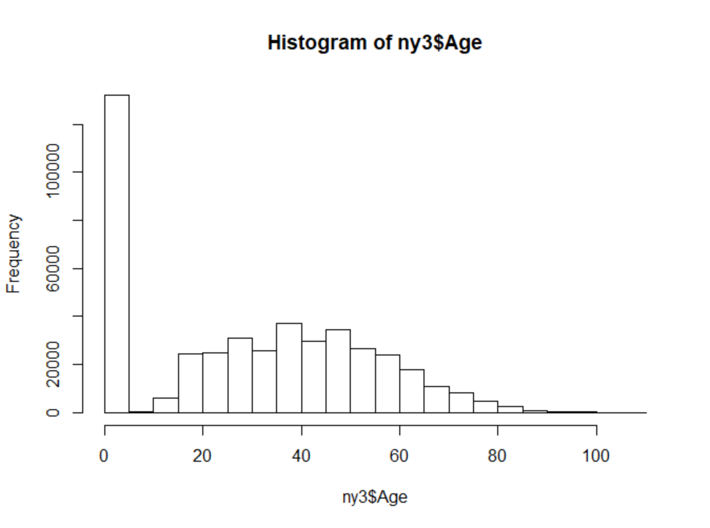

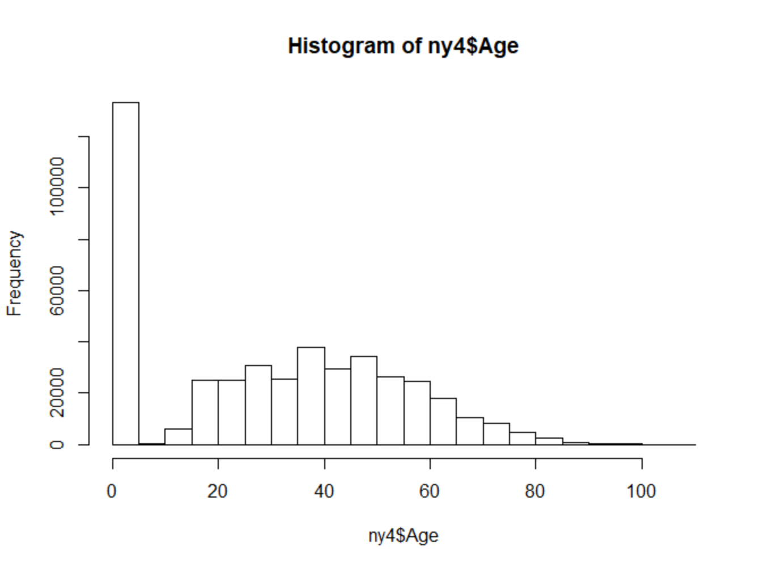

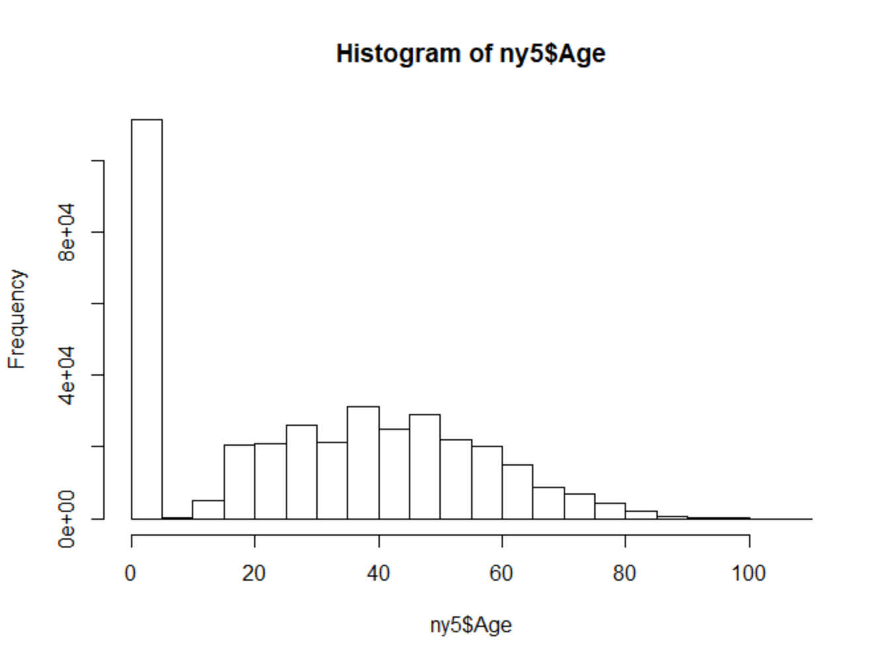

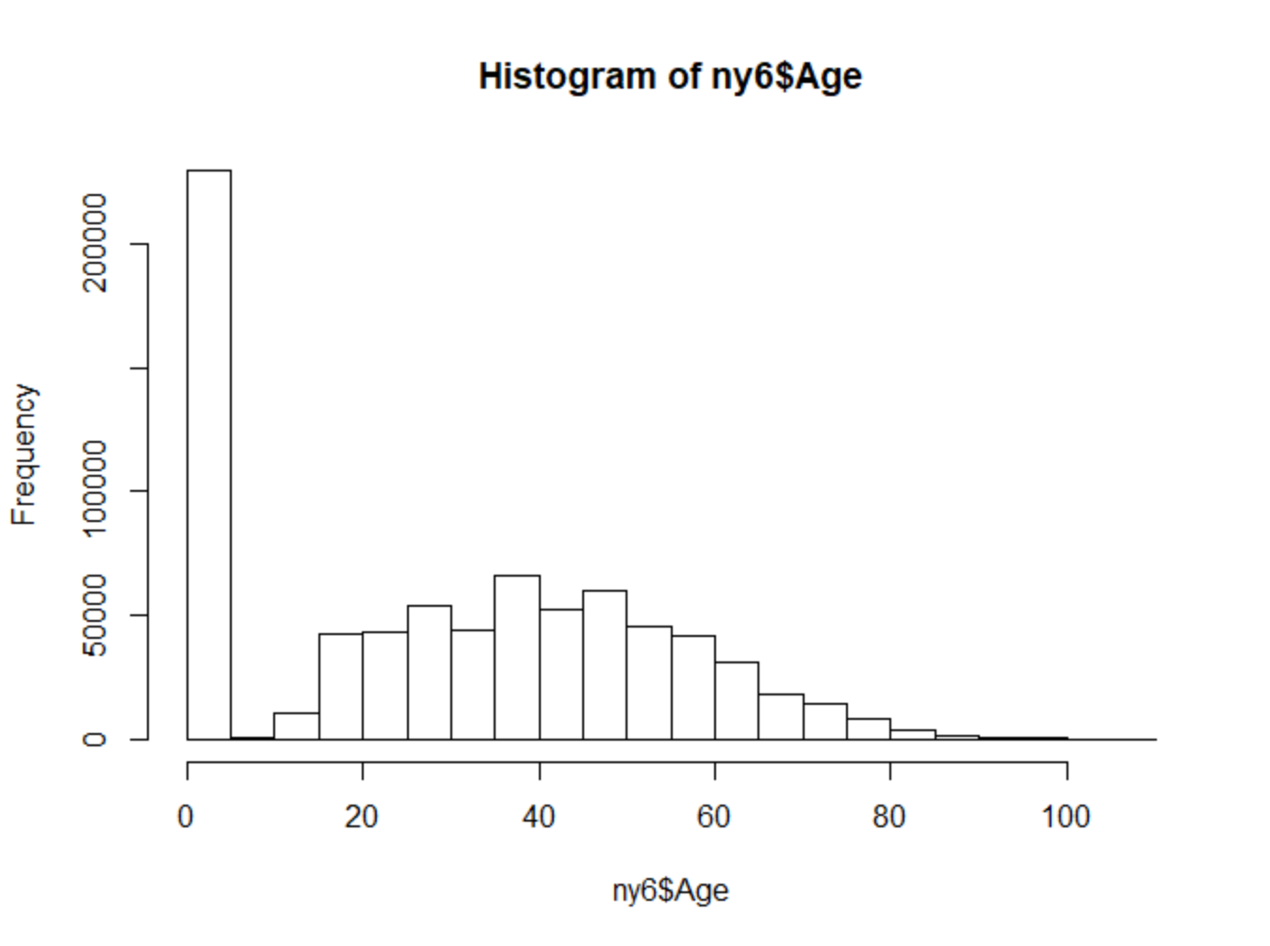

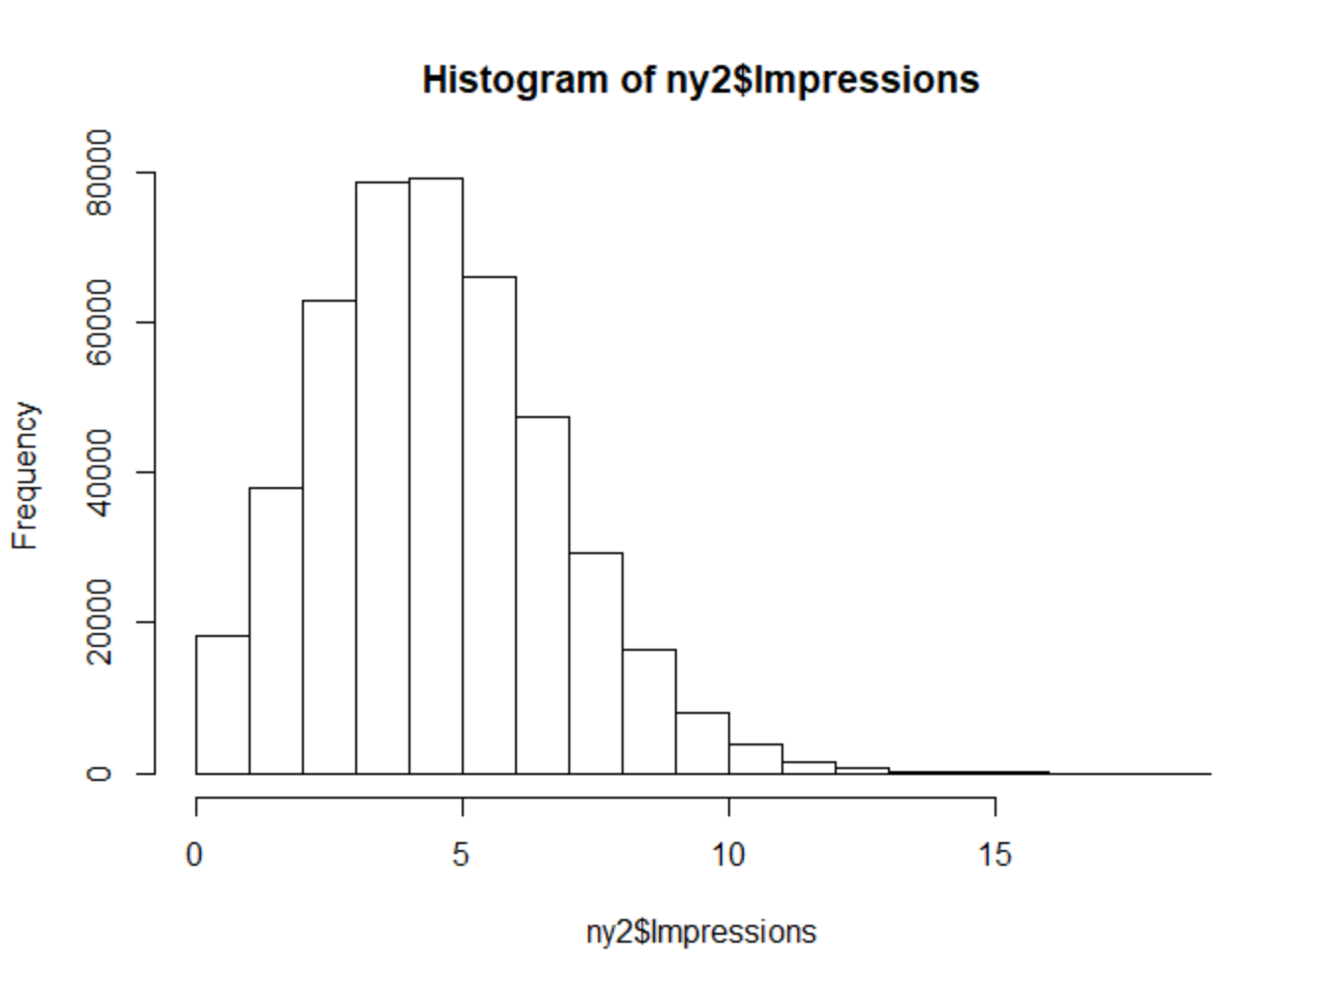

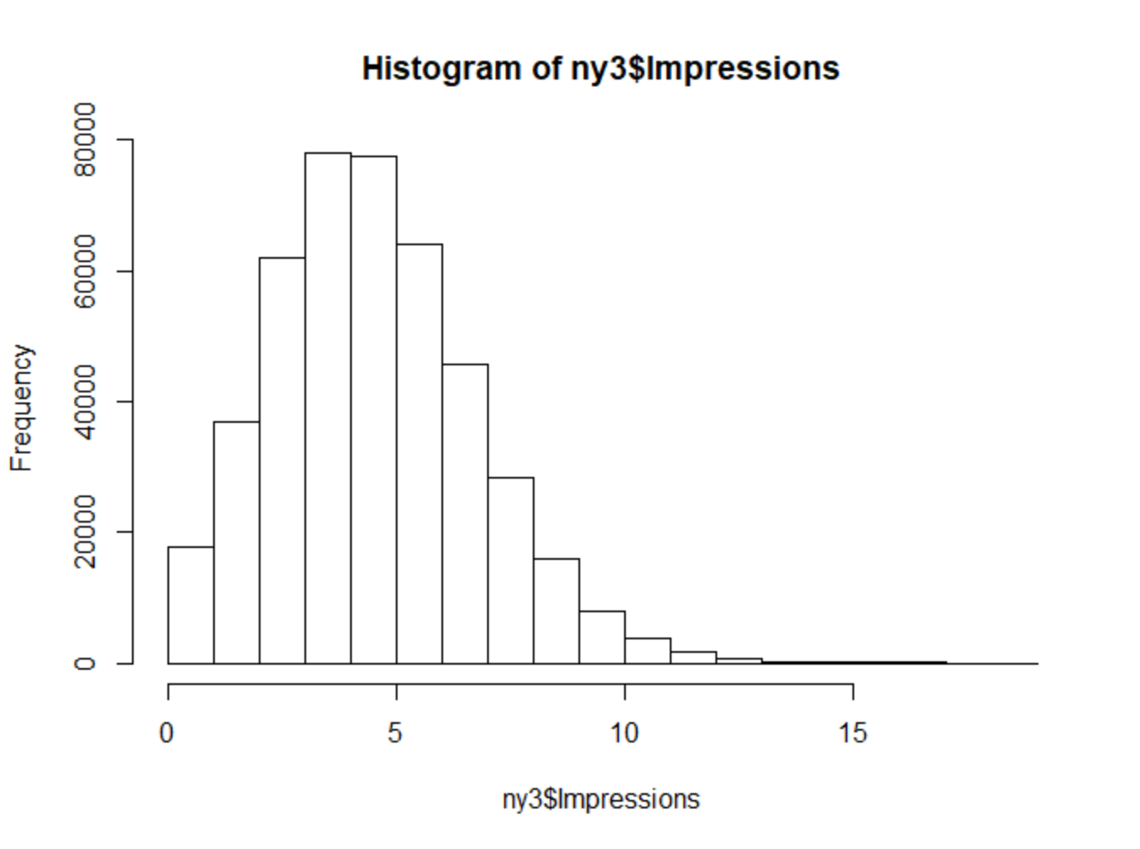

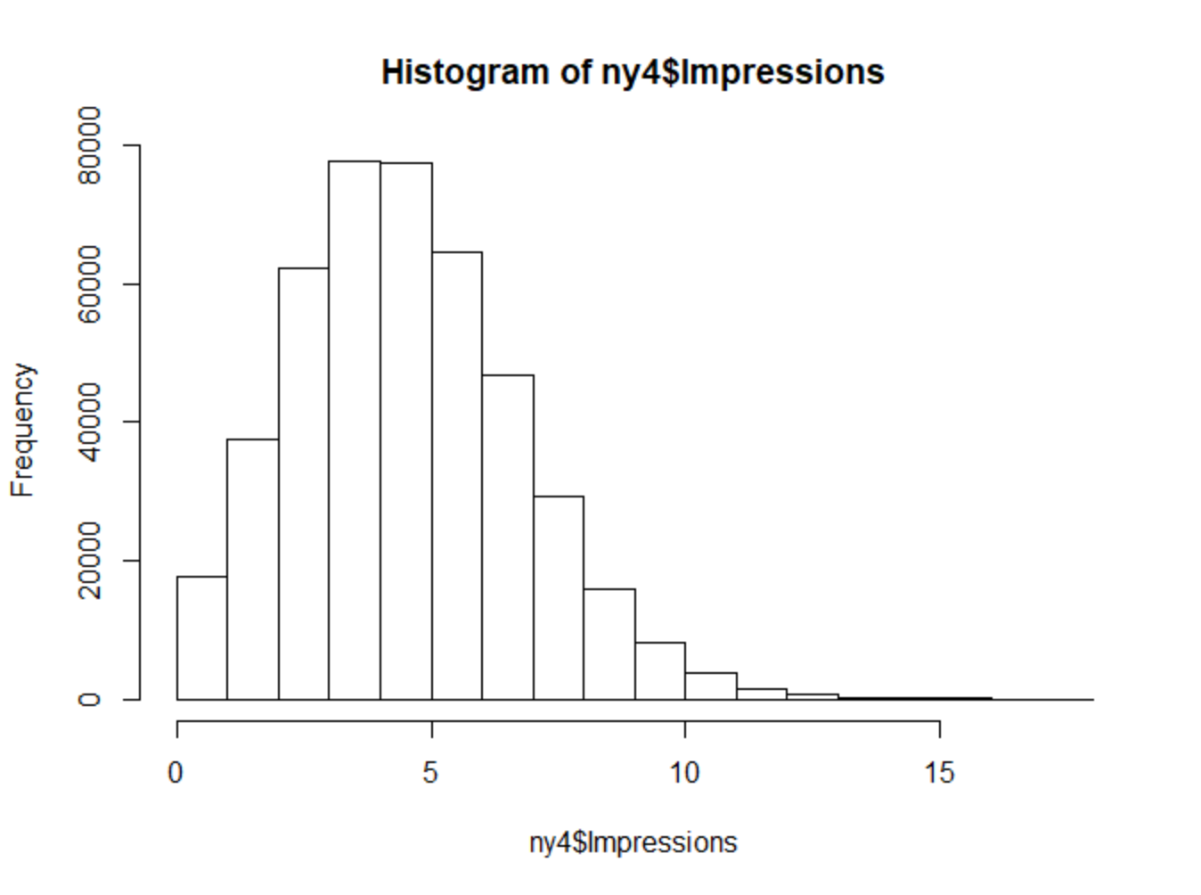

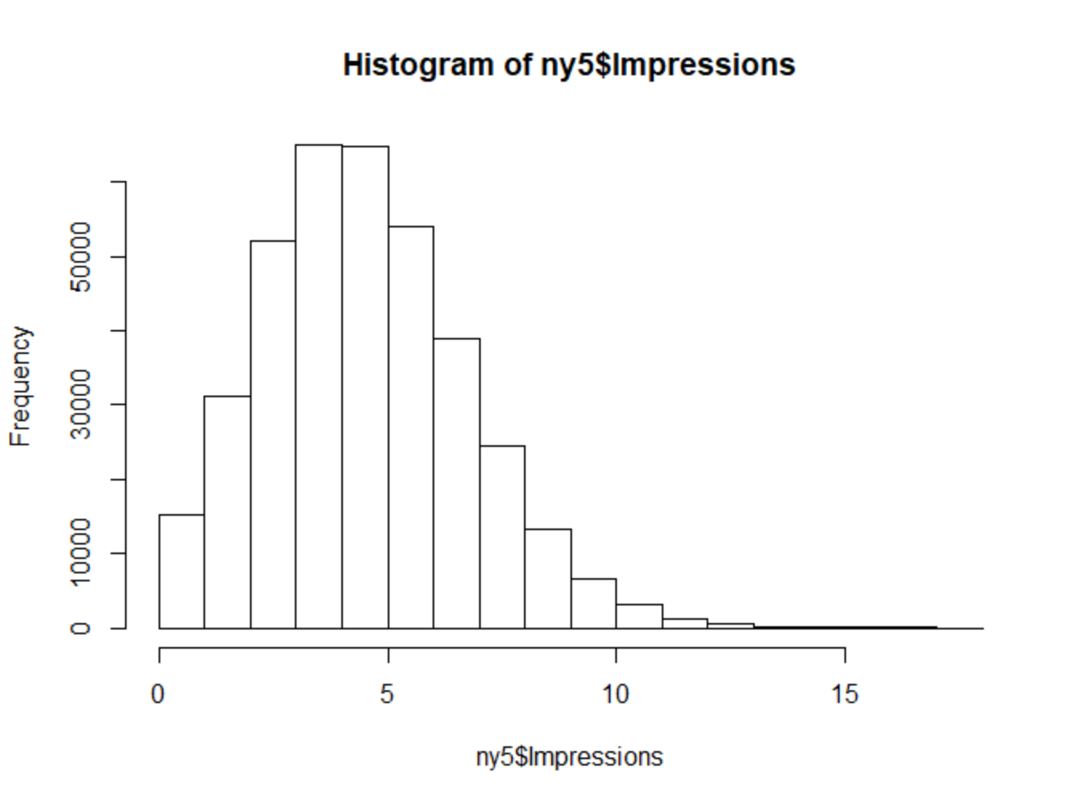

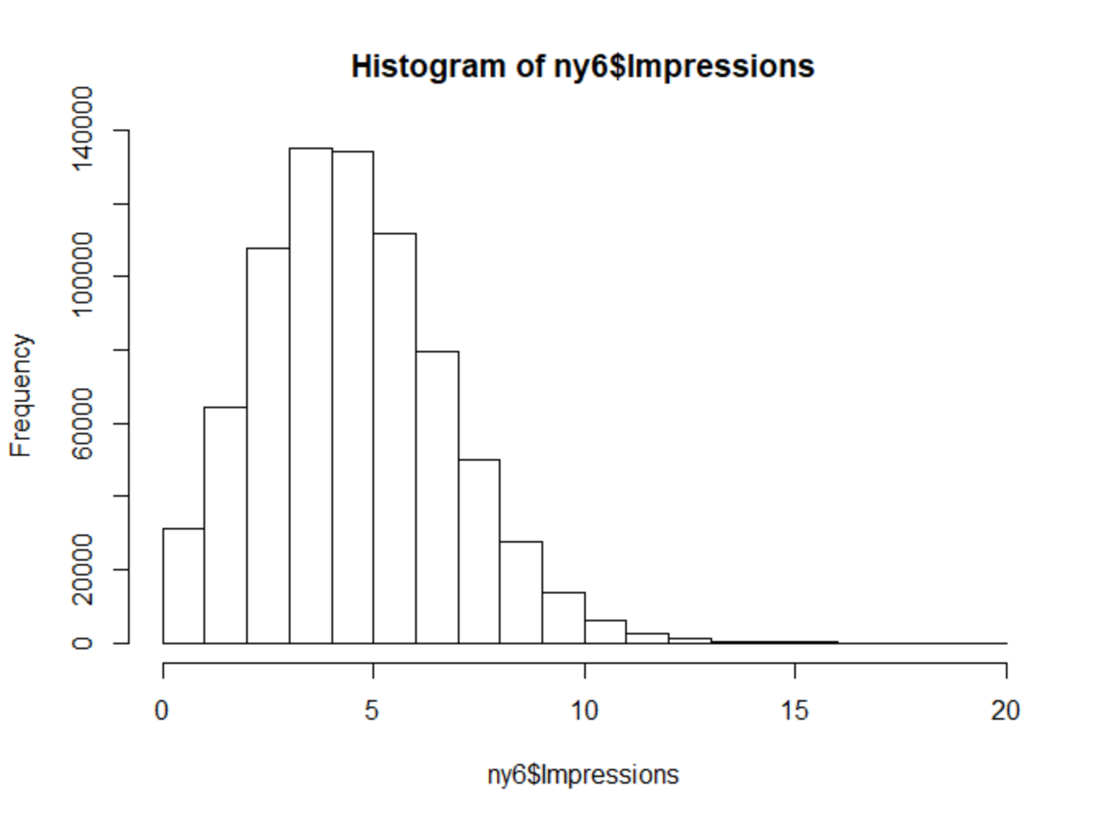

From the histograms, most New York Times readers ages from 20- 60. Most new York times readers have 3 – 6 impressions. The distribution of both age and impression are normal distribution.

c.

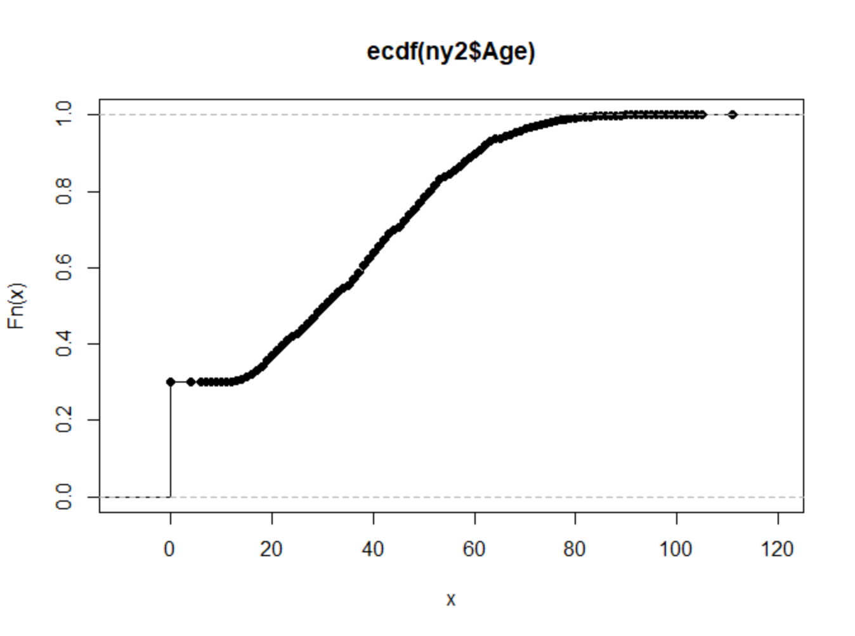

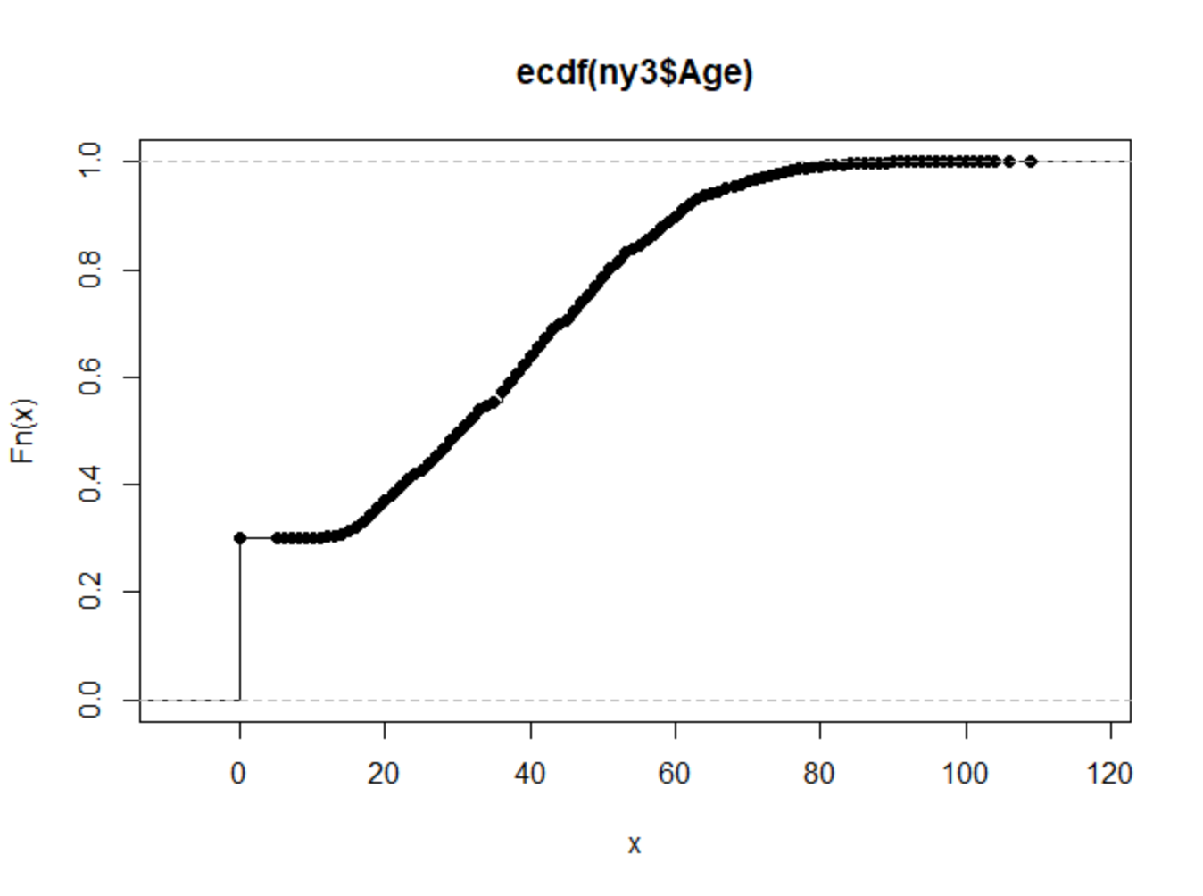

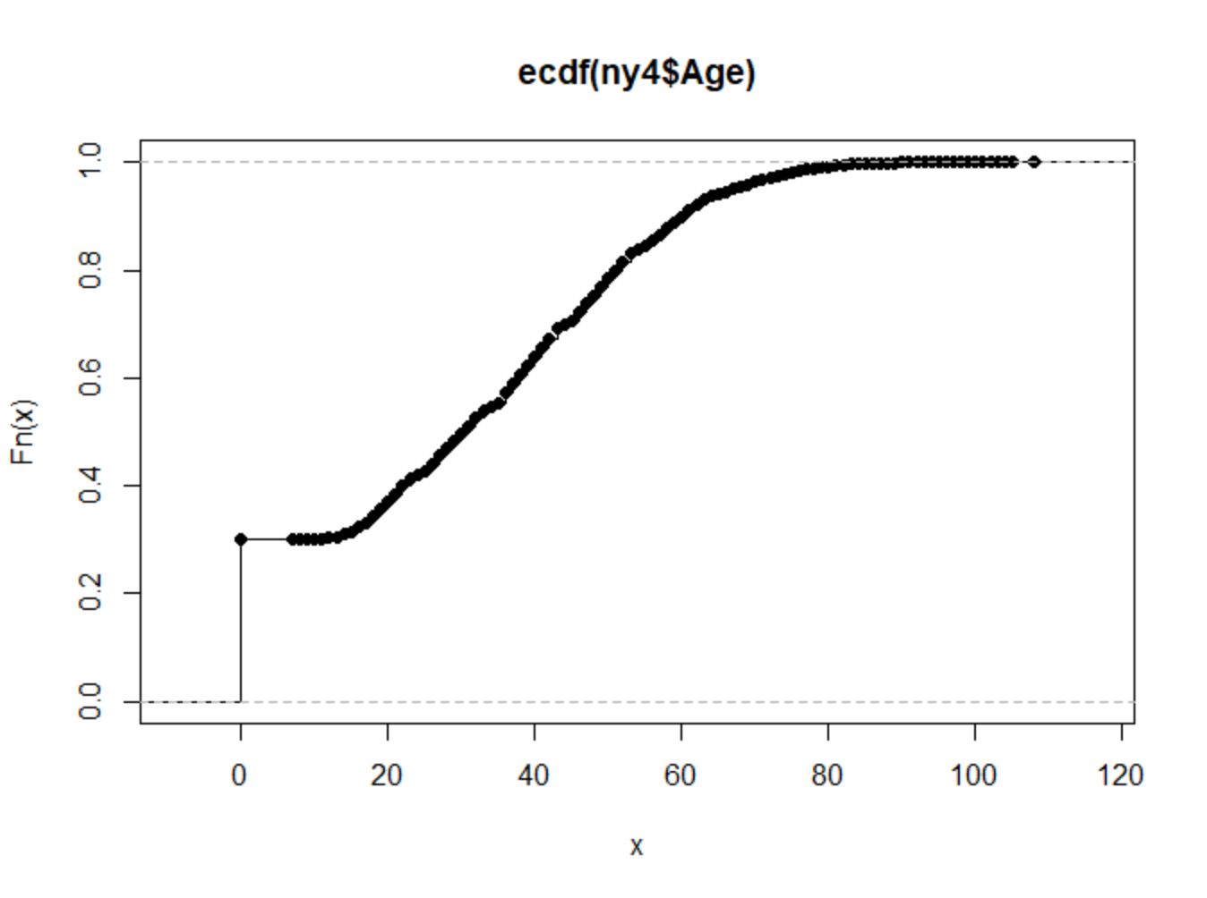

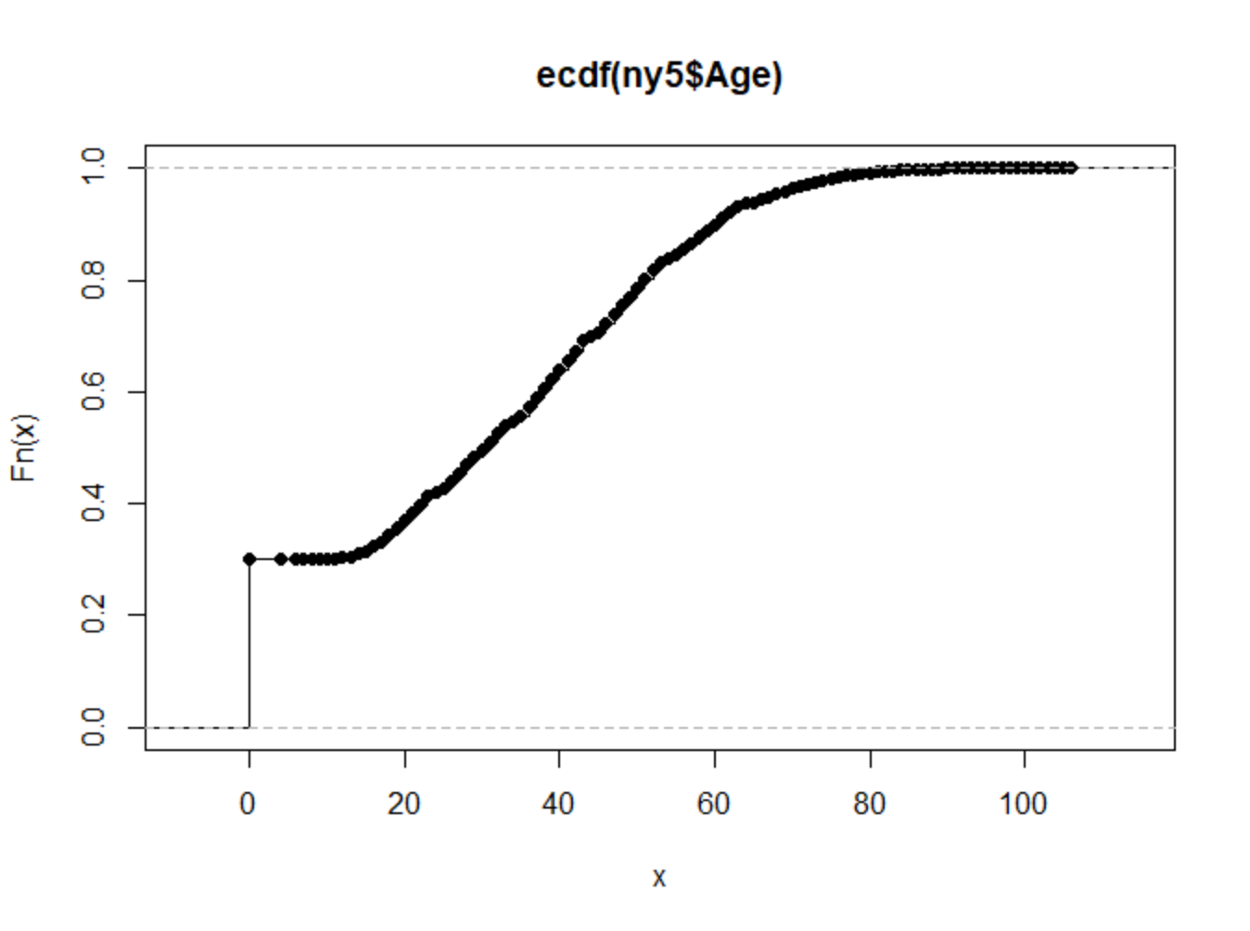

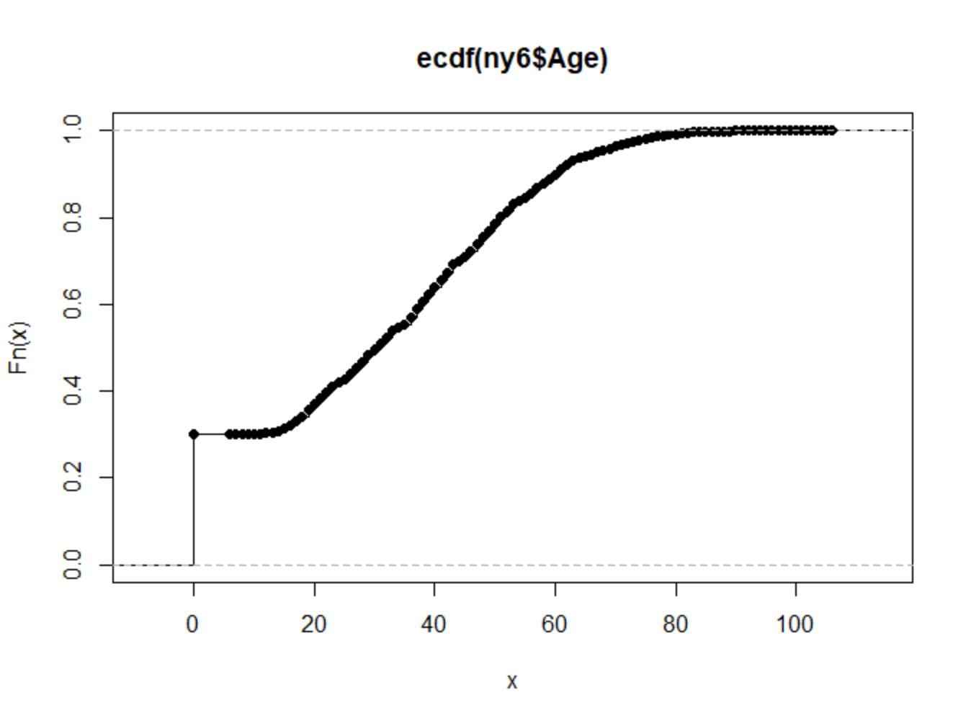

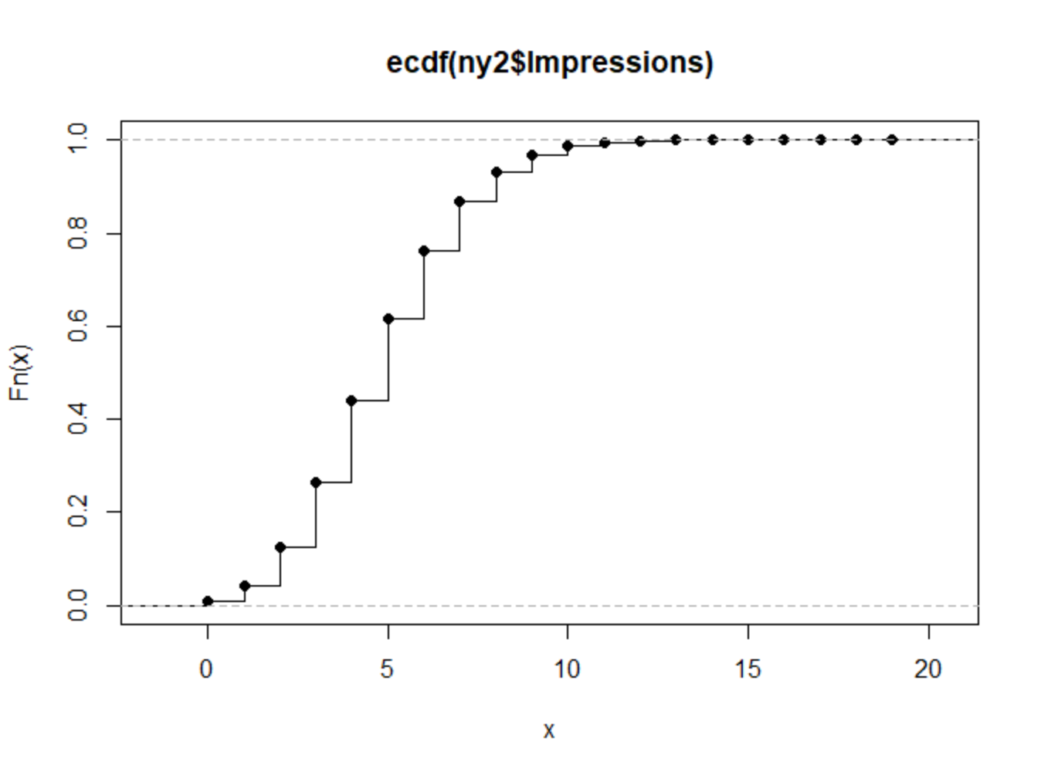

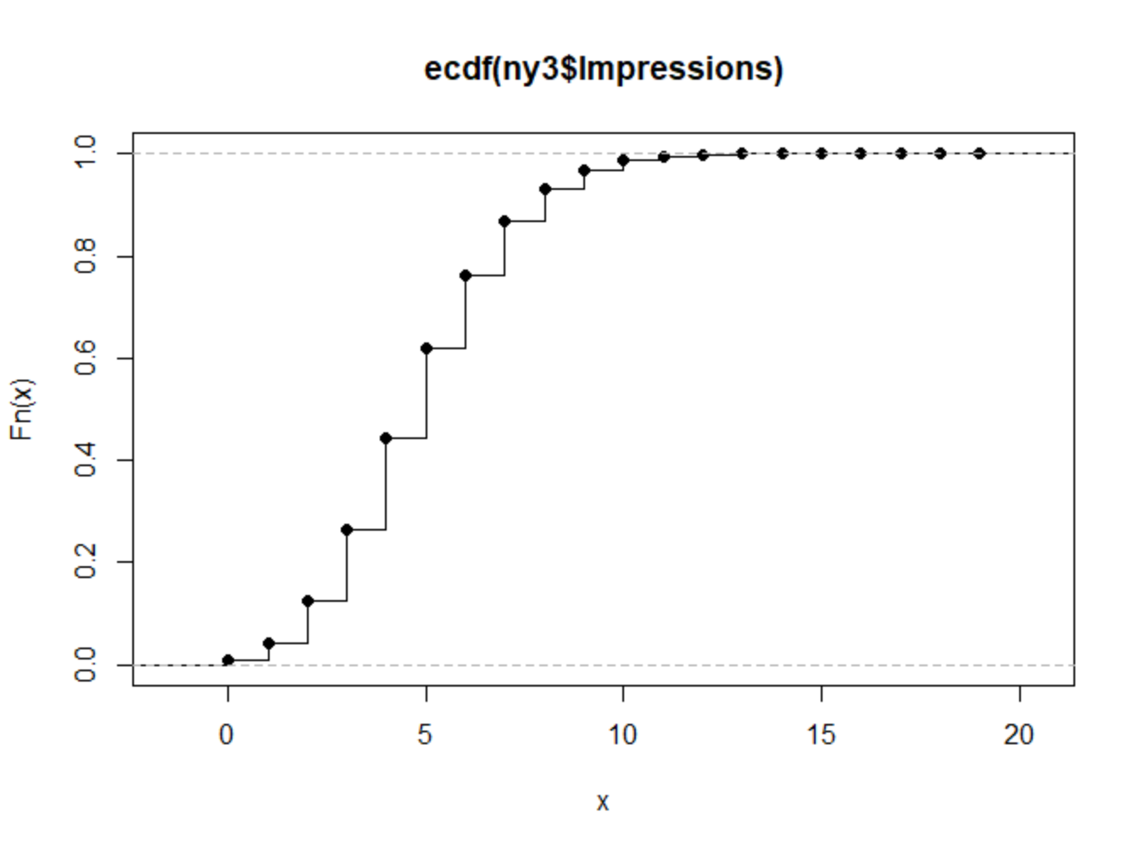

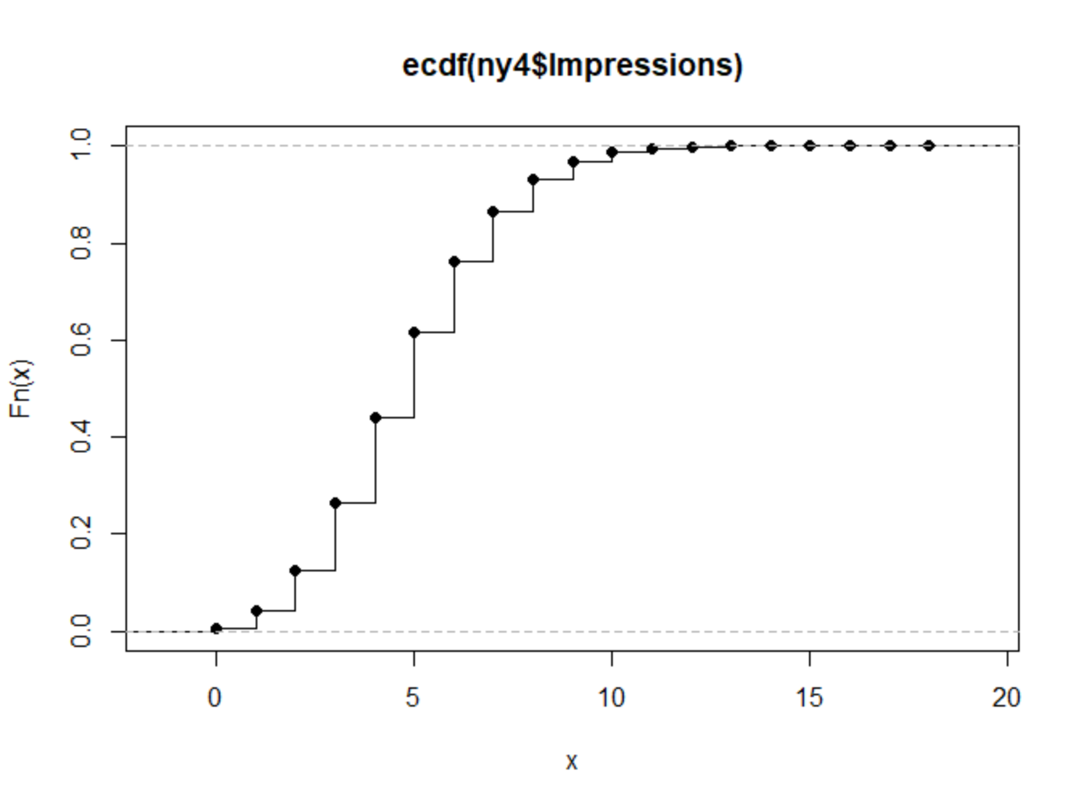

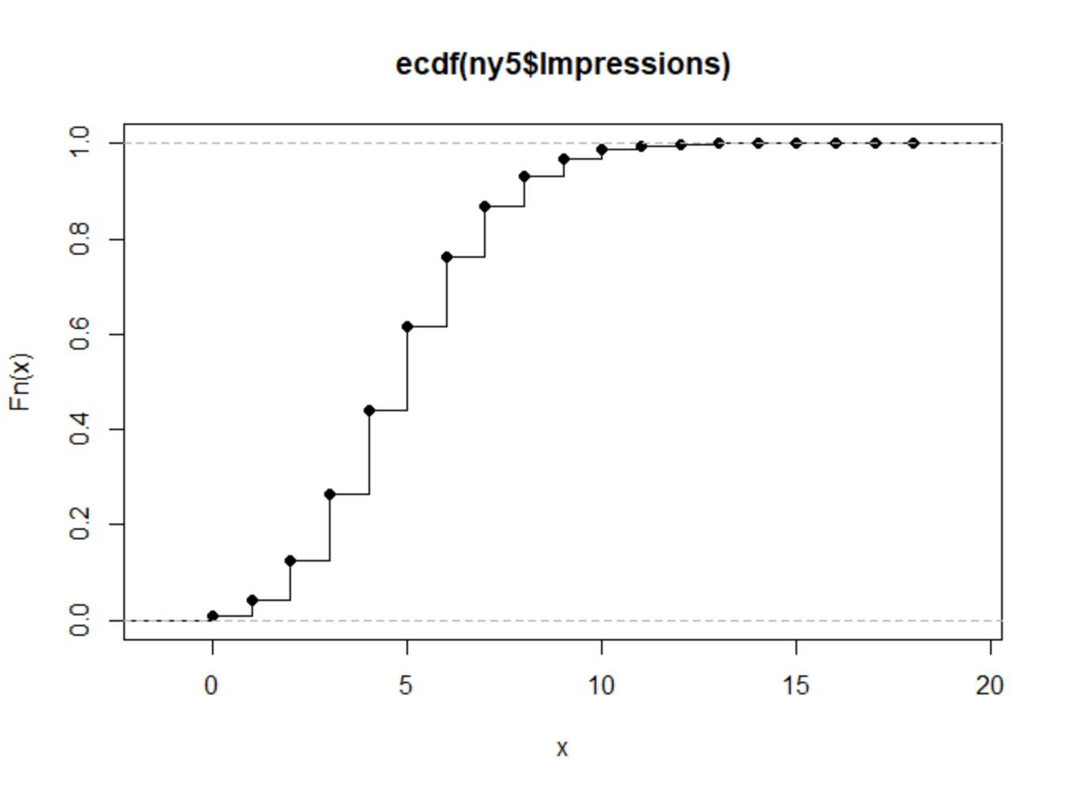

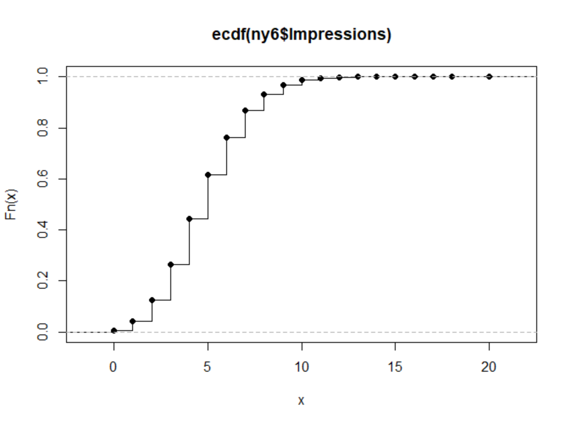

From the plot for ECDF of ages, we can find out that for most datasets, there are around 30% of people missing ages(age 0). There are also 60% of people less than age 40. From the plot for ECDF of impressions, we can find out that for most datasets, 50% of people have less than 5 impressions and less than 5 % of people have more than 10 impressions.

d.

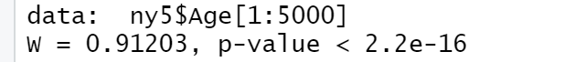

For Age variable in all 5 datasets, p-value is less than 0.05 which means the null hypothesis is invalid.

For Impression variable in all 5 datasets, p-value is less than 0.05 which means the null hypothesis is invalid.

Problem 2.

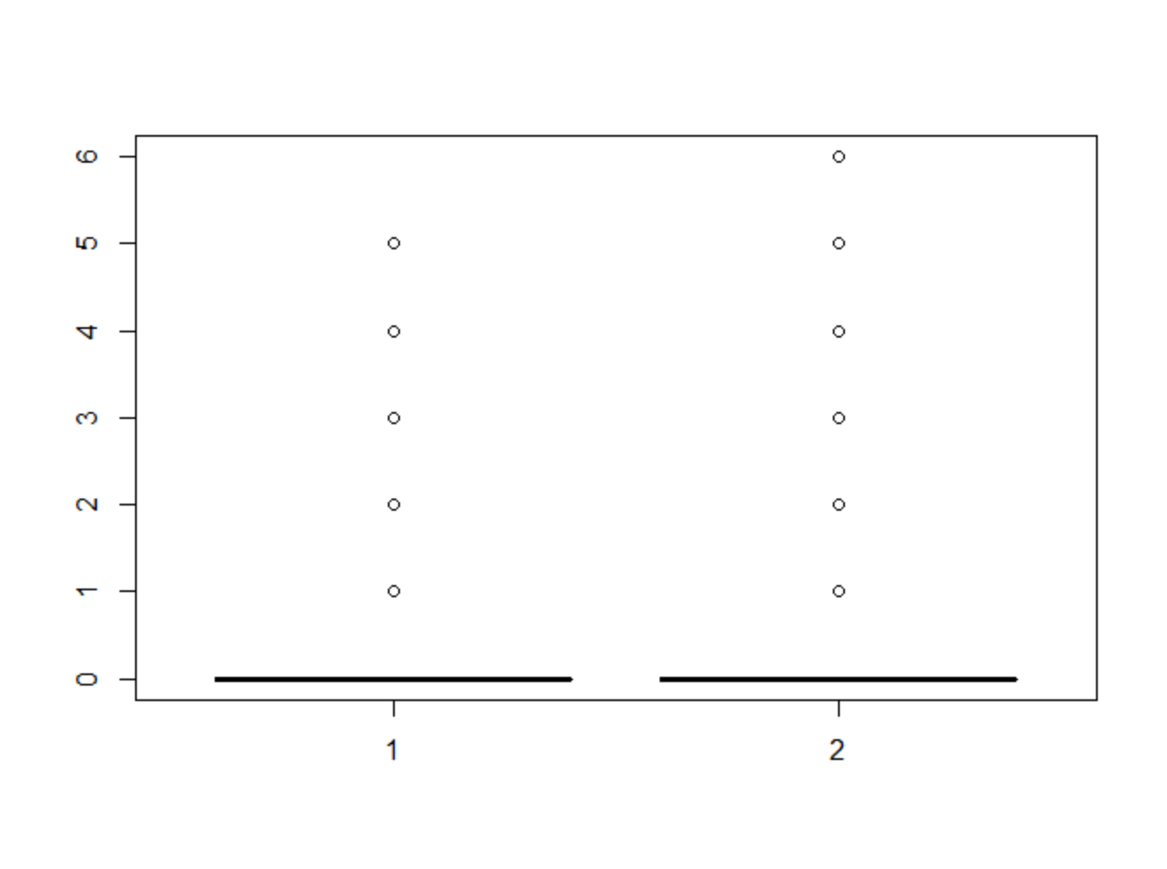

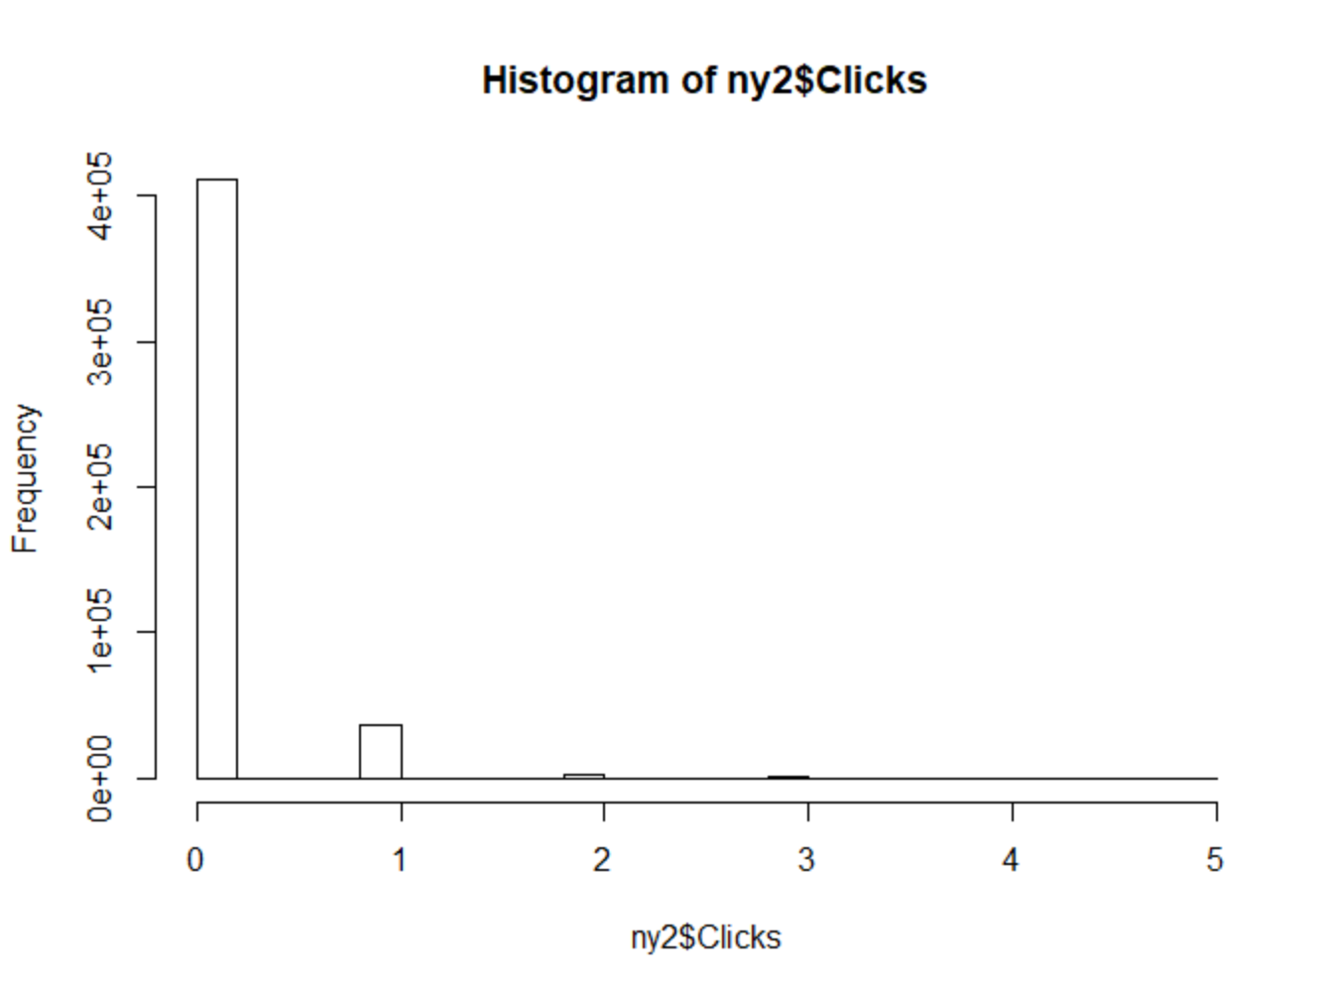

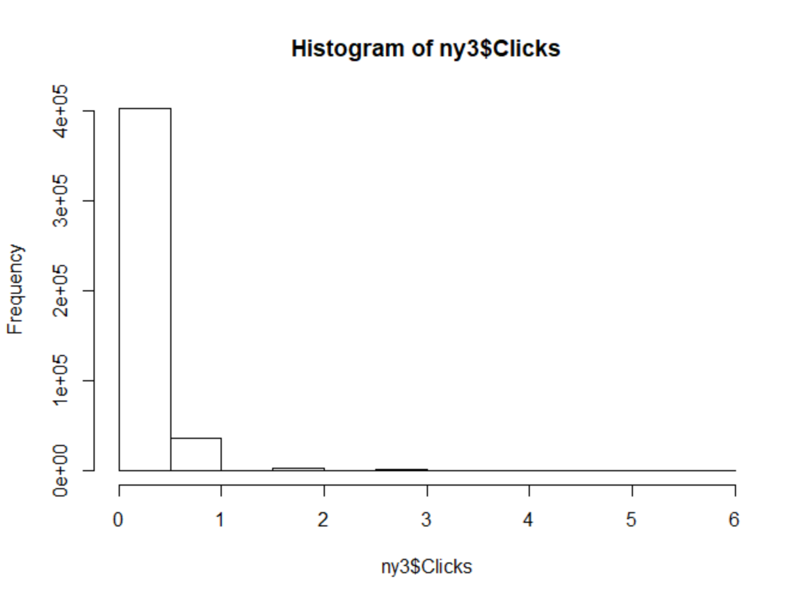

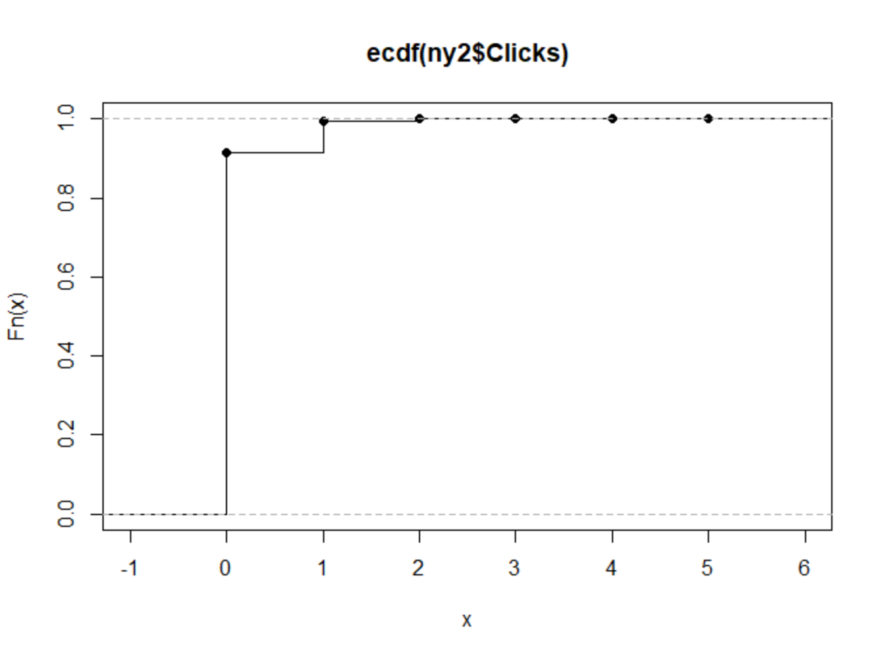

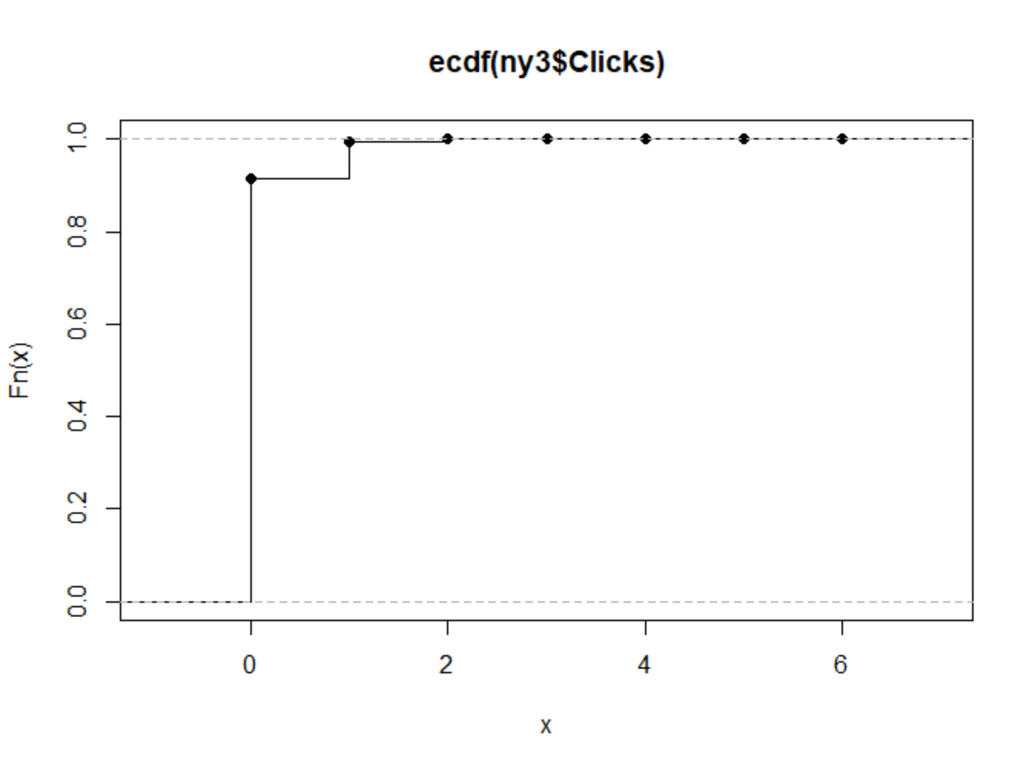

For the clicks variable, most people have 0 clicks. There are almost less than 1% of people who have more than 1 clicks. The max number of clicks is 6. The distribution of the clicks is right skewed distribution.